**Introduction to software engineering project**

**Depression diagnosis system**



**Supervisor: Dr.Mohammad sharaiaah**

Sebail AlBiltaji 0187771

Table of Contents

Introduction 3

1.1 background: 3

1.2 Problem definition: 3

1.3 Objectives: 3

1.4 Requirements: 4

1.5 Constraints: 4

1.6 Proposed solution: 4

1.7 Local & Global impact of the proposed solution: 5

2.0 feasibility study 5

2.1 technical feasibility 5

2.2 operational feasibility 5

2.3 economic feasibility 6

2.4 schedule feasibility 7

3.0 Software Requirements Document 7

3.1 Identify System Stockholders and Requirements Sources: 7

3.2 System Architecture: 8

3.3 User Requirement Definition: 8

3.4 System Functional Requirement Specification: 10

3.5 Non-Functional Requirements: 12

3.6 Requirements Scenarios 13

4.0 System Models and Design 21

4.1 context diagram 21

4.2 Use Case Models 22

4.4 sequence diagram 26

Patient sequence diagram 26

Appointment Admin sequence diagram 27

Psychologist sequence diagram 27

4.5 Class Diagram 28

4.6 Graphical User Interface Design 29

5.0 User Manual 30

5.1 Graphical User Interface Implementation 30

6.0 References: 33

# Introduction

## 1.1 background:

The COVID-19 pandemic has affected nearly every aspect of our life, COVID lockdowns haven’t happened for only one or two months, many people are now struggling with the effects of quarantine depression.

After 2 years of being at home, working from home, shopping from home, people are now facing a trouble in communications and they can’t deal with people anymore, all what they want is to be at home doing nothing.

No one will admit that there is a problem in their personalities and in real life people will feel guilty if they visit a psychologist or even if they tell other people they might feel ashamed, so in our application they can ask, interview, and even meet Psychologists with full privacy without anyone noticing.

## 1.2 Problem definition:

1-People refuse to reveal secrets and problems to doctors.

2-Doctors take advantages of patients and make them come a lot to increase the payment.

3- Finding good and reliable doctors is hard nowadays.

4-Doctors don’t always explain everything to the patient.

5-It’s hard to keep the doctor updated with everything going on in the patient’s life, sometimes discussing the problem with your doctor is the only solution.

6- The patient will keep feeling that they are different so the get people away from them ,trying to hide rather than getting appropriate treatment

## 1.3 Objectives:

In this application people can save effort, money and time by not visiting a psychologist in real life, they can just answer some questions about their personality and their problem that they are suffering, if the problem was not severe some advice will be given to the patient, if the problem was severe the patient will be transfer to a specialist doctor to give him the best treatment he might have.

So, our objectives of this application are as follows:

1. Give our patients the full privacy that they need.
2. Save effort, time, and money on our patients.
3. To give the best treatment to our patients by setting them up with the most qualified doctors.
4. It becomes easier to explain the problem to others and professionals when you know the definite name of the complication.
5. The patient needs to commit to the treatment plan and prescription. It creates a sense of responsibility, and they go after treatment.
6. The patient will get insight into the problem. They will understand themselves better and learn how to deal and manage with their thoughts and emotions rather than hiding them.

## 1.4 Requirements:

1. The system must be easy to use by non-technical people.
2. The system allows patients to search and view doctors’ profiles.
3. The system allows doctors to see their patients’ appointments and see their weekly schedules
4. Provide reports and feedback every 2 months.
5. The system must be secure.
6. The system allows secretary to give, cancel or update appointments.

## 1.5 Constraints:

In this application there might be some constraints regarding to the costs of building this type of application that requires having a lot of information about every condition, the costs of hiring good psychologists and the advertising of our application.

1. Development costs must not exceed 15,000 JDs.

2. The initial software application must be ready by December 30th

3. Security issues might delay the system.

## 1.6 Proposed solution:

We’re building a software that will help our society to overcome the emotional and mental damage caused by the pandemic with the help of a group of competent psychologists and a very simple and easy yet efficient web-based system which consists of the following:

* First, A homepage where you can log in to an existing account or sign up if it was your fist time using the website. If you choose the sign-up option, you’ll be directed to the sign-up page where you need to fill your information in a form to identify your ID and the data will be stored in a database.
* On the other hand, if you choose to log in you need to fill your username and password then press log in button and you’ll be directed to the homepage where you can access older sessions conversations and request a new session or you can choose ‘Homepage’ from the menu on top of the page to check for new updates, request to change your doctor -and state the reason- or you can choose ‘complains and suggestions’ from the menu on top of the page to give us a feedback on your experience so we can improve our services.
* Second, our psychologist’s full information and their appointments schedules are all saved in a database that is updated daily to keep up with the changes in their schedule and assign patients to them on their free time.
* Now after each session the psychologist needs to write a report and add it to the patient record, he/she created so that they would be able to monitor the patient’s condition.

## 1.7 Local & Global impact of the proposed solution:

Locally: our system will help people with mental illnesses to understand and learn more about their condition and how to deal with it so they can be back on track with their daily lives and provide consultant to.

Globally: If the software was successful in Jordan and affected possitively on the society and helped people the idea might start spreading in other countries and hopefully reach many more people and help them get treated and strong mentally and physically.

# 2.0 feasibility study

## 2.1 technical feasibility

Our project is a web-based application, the main technologies and tools that are associative with are

- HTML5

- CSS

-JavaScript

-PHP for web development

## 2.2 operational feasibility

Web applications are familiar to users widely, and you don't need much training on them, they are easy to use. Users of this application will also be provided with a tool that saves them time and effort, which are two main points that users are looking for. This app is initially expected to run without problems due to usability and user background focus on its development

## 2.3 economic feasibility

A- Development costs:

1. Employees:

Table I: Employee Development Costs

|  |  |  |  |
| --- | --- | --- | --- |
| Employee Type | Cost per hour | Number of hours | Total cost per  hour |
| System Analyst | 55 JD | 30 | 1650 JD |
| System Administrator | 30 JD | 15 | 450 JD |
| Programmer | 20 JD | 20 | 400 JD |
| GUI designer | 10 JD | 120 | 1200 JD |
| Data warehouse | 15 JD | 15 | 225 JD |

|  |  |
| --- | --- |
| Total | 3925 JD |

2. Hardware and software:

Table II: Hardware and Software Development Costs

|  |  |
| --- | --- |
| Name | Cost |
| Development Server | 700 JD |
| Computer | 500 JD |
| DBMS Software | 300 JD |
| Total | 1500 JD |

|  |
| --- |
| Total of Development cost is: 3000 JD |

B- Operating cost:

Table III: Operating Costs

|  |  |
| --- | --- |
| Name | Cost |
| Content and marketing manger | 600 JD |
| Programmer | 1500 JD |
| System Update and Enhancements | 900 JD |
| Devices Maintenance | 800 JD |
| Total | 3800 JD |

## 2.4 schedule feasibility

Starts from 14/11/2021 to 30/12/2021

|  |  |
| --- | --- |
| Work description | Working days |
| Initializing | 4 days |
| Analyzing system needs | 12 days |
| Feasibility study | 4 days |
| Designing the system | 16 days |
| Documenting software | 6 days |
| Testing and maintaining | 2 days |

# 3.0 Software Requirements Document

## 3.1 Identify System Stockholders and Requirements Sources:

|  |  |  |
| --- | --- | --- |
| SK # | Name | Description |
| SK1 | Admin | The administrator of the system will manage the system. |
| SK2 | Users | The user will have the permissions of the user’s account. |
| SK3 | Psychologist | The user will have the permissions of the psychologist account. |

## 3.2 System Architecture:

## 3.3 User Requirement Definition:

* Administrator Section:
  + 1. Login: The administrator can access the system with a special username and password.
    2. Logout: The administrator can log out from the system by sending a request to end the current session.
    3. Users Management: The administrator will manage the user’s table including the following functions (Edit, Delete and Display).
    4. Psychologist Management: The administrator will manage the psychologist table including the following functions (Add, Edit, Delete and Display).
    5. Requests Management: The administrator will manage the requests table including the following functions (Delete and Display).
* Psychologist Section:
  + 1. Login: Psychologists can access the system with a special username and password.
    2. Logout: Psychologists can log out from the system by sending requests to end the current session.
    3. Requests Management: Psychologists will manage the requests table including the following functions (Edit, Delete, and Display).
* Users Section:
  + 1. Signup: The user will make the signup process inside the system.
    2. Login: The user can access the system with a special username and password.
    3. Logout: The user can log out from the system by sending a request to end the current session.
    4. Requests Management: The user will manage the requests table including the following functions (Add, Edit, Delete, and Display).

## 3.4 System Functional Requirement Specification:

* Administration Section:
  1. Login: The administrator will access the administration section through the admin login area after entering the username and the password for that admin. This shall be the basis for determining the class privilege corresponding with the assigned admin username and password. The login should be validated before access to the system is approved.
  2. Logout: The administrator can log out from the system by pressing on logout button to destroy the current session.
  3. Users Management: The administrator can manage users’ tables after successful login to the administrator area by active all management functions (Edit, Delete and Display the table list).
  4. Psychologist Management: The administrator can manage the psychologist table after success login to the administrator area by active all management functions (Add, Edit, Delete, and Display the table list).
  5. Requests Management: The administrator can manage the requests table after success login to the administrator area by active all management functions (Delete and Display the table list).
* Psychologist Section:
  1. Login: The psychologist will access the psychologist section through the psychologist login area after entering the username and the password for that psychologist. This shall be the basis for determining the class privilege corresponding with the assigned psychologist username and password. The login should be validated before access to the system is approved.
  2. Logout: The psychologist can log out from the system by a press on logout button to destroy the current session.
  3. Requests Management: The psychologist can manage the requests table after success login to the psychologist area by active all management functions (Edit, Delete and Display the table list).
* Users Section:
  1. Signup: After entering all needed information, the users will sign up to make an account to give the users access to the system in the user’s area.
  2. Login: The user will access the user section through the user login area, after entering the username and the password for that user. This shall be the basis for determining the class privilege corresponding with the assigned user username and password. The login should be validated before access to the system is approved.
  3. Logout: The user can log out from the system by a press on logout button to destroy the current session.
  4. Requests Management: The user can manage the requests table after success login to the user area by active all management functions (Add, Edit, Delete and Display the table list).

## 3.5 Non-Functional Requirements:

|  |  |  |
| --- | --- | --- |
| # | Title | Description |
| 1 | Security | Our system is fully secure by a username and password for the administrator, to make sure all the control features are only with the admin. Also, each user inside the system has an encryption password using the MD5 algorithm. |
| 2 | Performance | The system should run fast with no propagation, to provide the best service in making requests between users and psychologists. |
| 3 | Reliability | The system should be as reliable as possible since we have critical information about requests, psychologists, and users. |
| 4 | Ease Of Use | Our system has a friendly interface that can be used by different users. |
| 5 | Availability | Our system will be available for all users through a web application and using web browsers, and this system will be available for users anywhere and anytime through internet service once they need it. |

## 3.6 Requirements Scenarios

**For psychologist**

**For appointments Admin:**

**For patient**

Appointment

Adamin

# 4.0 System Models and Design

## 4.1 context diagram

psychologist

Treatment methods view patient info

0

Depression diagram

system

Patients

Treatment plan

Appointment Reminders

Therapy request

Questions approve

Appointments

and send

reminders

answer

Questions

Appointment

Admin

## 4.2 Use Case Models

**4.3 Senario**

|  |  |  |
| --- | --- | --- |
| Description | User can create their own account by  filling in the required fields, then the user  clicks on “Submit” button and receive the  verification code (based on his phone  number) which leads to creation of the  Password for his account. | Employee’s information is saved in database -IT  staff has entered his information and verified it  already (no registration needed from the  Employee). All they need to is sign in only. |
| Data | Username (first, middle and last name), E-mail, phone number, living address, and nationality. | ID number, Username (first, middle, and last  name), E-mail, phone number, living address,  nationality, and position |
| Stimulus | User clicks on the “Submit” button. | IT worker clicks on the “Create” button. |
| Response | A personal account successfully created. | A personal account successfully created. |
| Comment | The user must fill all the information  Required correctly. | The IT worker must fill all the information  Required correctly. |

**Actors Patient psychologists**

*Tabla I: Senarios – Register*

Actors psychologists

|  |  |
| --- | --- |
| Description | User can view available appointments provided by the clinic and book an  Appointment that suits them. |
| Data | Username, E-mail, phone number, and Time. |
| Stimulus | User clicks on the “Submit” button. |
| Response | User’s information is saved on database and an email with all the appointment  Details sent to the user. |
| Comment | The user must enter the phone number and the email correctly |

*Table II: Scenarios – Depression diagnoses, test and appointment*

Actors psychologists

|  |  |
| --- | --- |
| Description | The psychologists can view the patient’s file and information (diagnosis results, personal  Information, advice and so on). |
| Data | Patient’s personal information and the treatment summary. |
| Stimulus | The psychologists click on “View File” button to view the patient’s file and  Information. |
| Response | The system will let the psychologists to see all patient’s information. |

*III: Scenarios - View Patient's File Table*

Actors Admin

|  |  |
| --- | --- |
| Description | The admin approves the received applies  Then sends the details of the diagnosis and the appointment to start treating sessions to the patient. |
| Data | Patient’s contact information and appointments details. |
| Stimulus | User command issued by the admin. |
| Response | A confirmation notification sent to the patient. |
| Comment | The admin must have appropriate security permissions to access the patient  Information. |

*Table IV: Scenarios – Approving appointments details and Sending Reminders to the Patients*

Actors Patient

|  |  |
| --- | --- |
| Description | The patient fills a form of his/her information to create an account. |
| Data | Patient’s first name, last name, username, e-mail, phone number-optional-, password and password confirmation. |
| Stimulus | The patient clicks on the ‘sign up’ button. |
| Response | A confirmation message sent to the patient’s e-mail or phone number. |
| Comment | The patient must enter their contact details correctly. |

*Table V: Scenarios – Patient Login*

Actors Patient

|  |  |
| --- | --- |
| Description | The patient requests booking an appointment after choosing the suitable date and time. |
| Data | Patient’s first name, last name, record of previous sessions if he/she has one. |
| Stimulus | The patient clicks on the ‘Book an appointment’ button. |
| Response | A message with the session details would be sent to the patient’s e-mail or phone number. |
| Comment | The patient must choose a suitable time. |

*Table VI: Scenarios – Book appointment*

Actors Patient

|  |  |
| --- | --- |
| Description | The patient requests cancelling a booked appointment. |
| Data | Patient’s first name, last name, e-mail or phone number |
| Stimulus | The patient clicks on the ‘Book an appointment’ button. |
| Response | A message confirming the cancellation would be sent to the patient’s e-mail or phone number. |
| Comment | The patient appointment is cancelled. |

*Table VII: Scenarios – Cancel appointment*

## 4.4 sequence diagram

### Patient sequence diagram

### Appointment Admin sequence diagram

### Psychologist sequence diagram

## 4.5 Class Diagram

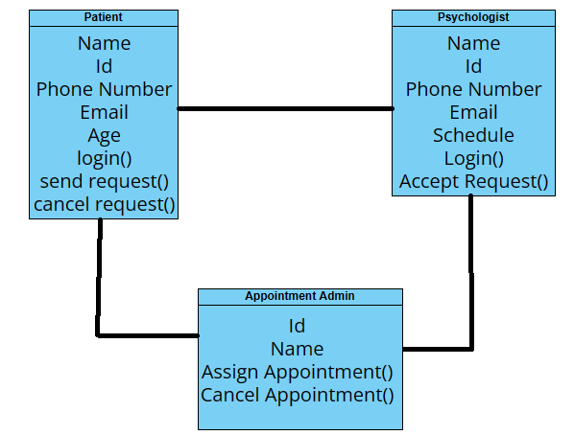

## 4.6 Graphical User Interface Design

Sign up and log in pages

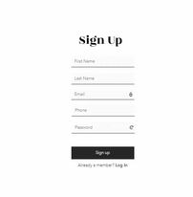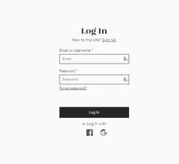

Homepage

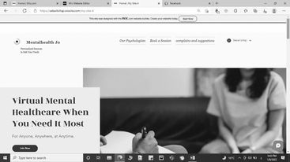

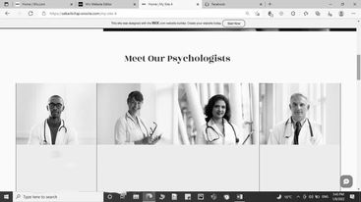

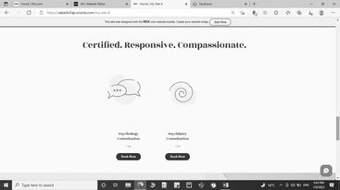

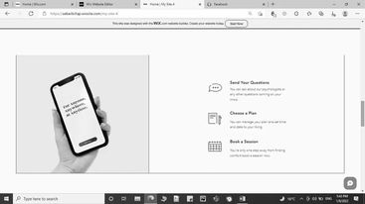

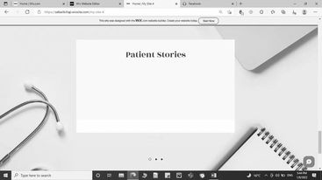

# 5.0 User Manual

## 5.1 Graphical User Interface Implementation

Homepage

Here’s the main menu where the user can navigate through the website.

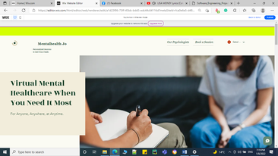

Here’s the user profile where he/she can view their booked appointments or edit their profile information.

User profile

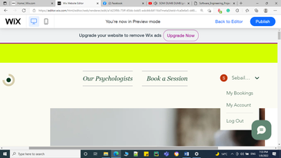 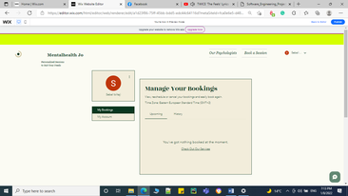

My Bookings page

My Account page

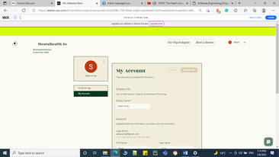 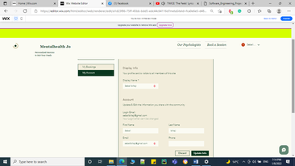

If user clicks on Log Out they will be directed to the Homepage where they can view our services and get to know our psychologists but they will have to log in if they want to book an appointment as follows

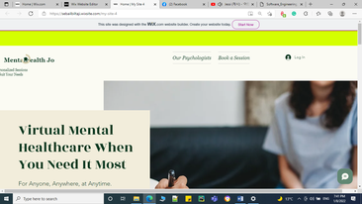

Now if they click on Log in the following page will appear

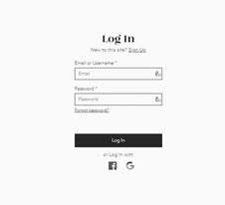 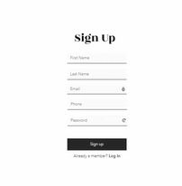

If they click on Sign up

Now back to our Homepage

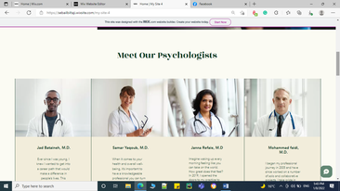

Our psychologists and some information about them are displayed on the Homepage.

Some further information about the website are written on the Homepage.

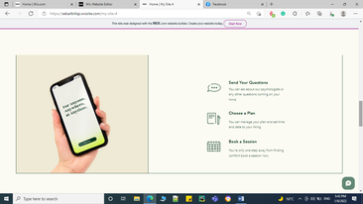

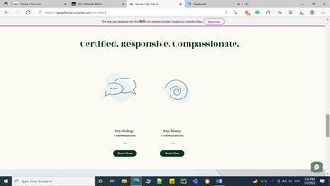

Here’s where the patient chooses a session and books it.

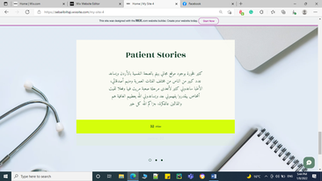

Patient stories are displayed on the Homepage to encourage other people to get appropriate treatment.

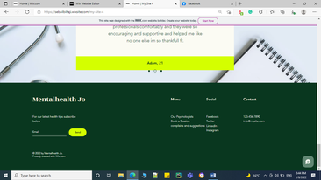

In the bottom of our page users can subscribe in a service using their email so we can send them the latest health tips.

If you click on this button you can write your suggestions, ask questions and give us your feedback about our services.

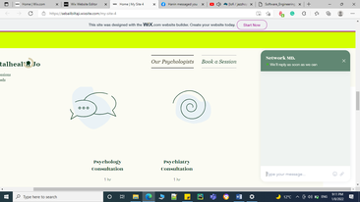

The website link: [Home | My Site 4 (wixsite.com)](https://sebailbiltaji.wixsite.com/my-site-4)

# 6.0 References:

1- Lucid (<https://lucid.app>).

2- draw.io ([Untitled Diagram - diagrams.net](https://app.diagrams.net/)).

3- visual paradigm ([Free Class Diagram Tool (visual-paradigm.com)](https://online.visual-paradigm.com/diagrams/solutions/free-class-diagram-tool/?fbclid=IwAR3XCA5cR45iTsJrc0pWTMa14wAlU7ZrafvnmY0P2V3Pnq2Q-jK984rxJ0U)).

4-Ian Sommerville. Software Engineering (10th Edition). Addison Wesley, 2015.